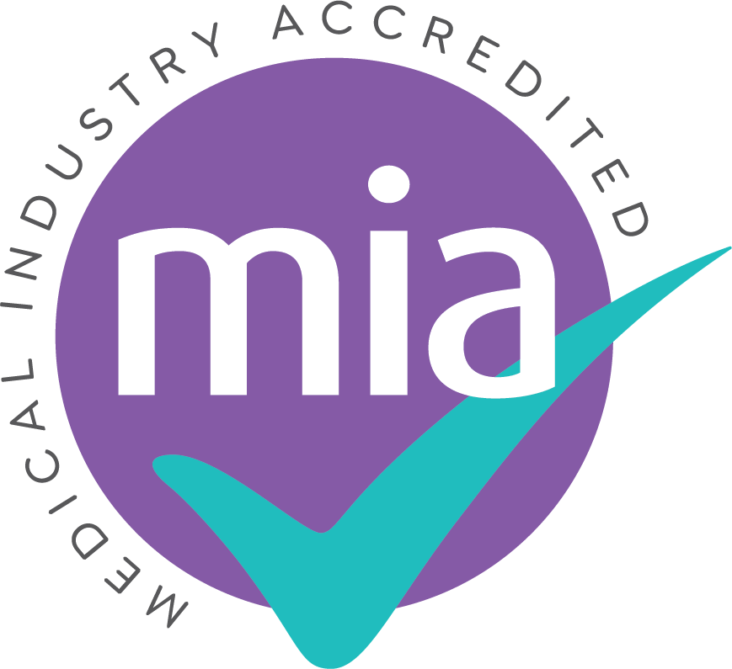
How to arrange Enhanced DBS checks
for medical sales representatives
A short, practical route for medical supplier companies

The process
Write an accurate role description. State what the representative genuinely does: areas visited, frequency, clinical demonstrations or training, who receives them, whether patients are present, and the degree of contact with children or adults receiving healthcare.
Choose a DBS umbrella body. Use the official GOV.UK directory. Ask whether the provider handles medical supplier roles, what evidence it needs to confirm eligibility, its administration fee, typical processing route, identity options and whether it supports self-employed applicants where relevant.
Submit the company request. The employer or umbrella body selects the appropriate check and workforce, confirms that the role is eligible and sends the representative a secure application invitation. Do not select a barred-list check simply because it appears more comprehensive.
Help the representative prepare. They will normally need all previous names, a complete five-year address history and identity documents that meet the provider’s current DBS route. Documents should be valid, legible and show the correct current details.
Track and review the certificate. Keep the application reference and use DBS tracking. The paper certificate is sent to the applicant. The company should inspect the original, make its suitability decision and record only the evidence it genuinely needs.
Use the Update Service. Encourage the representative to join promptly. For paid roles it currently costs £16 a year and registration must be made while the application is in progress or within 30 days of the certificate issue date.

One important check before applying Pure sales activity is normally eligible for a Basic DBS check only. Enhanced eligibility may arise from the actual duties or setting, for example, demonstrating the safe use of equipment to a patient or regulated healthcare professional. Give the umbrella body the full facts and let it confirm the correct level.

Suggested wording for the umbrella body
Copy, complete and amend “We employ [name/job title] as a medical sales representative. They visit [Trusts/sites/departments] approximately [frequency]. Their duties include [sales discussions / equipment demonstrations / clinical training / technical support]. Demonstrations are provided to [patients / regulated healthcare professionals / other staff], with [describe any patient presence or contact]. An NHS Trust has requested [Enhanced level, workforce, barred-list position and recency]. Please assess the role and confirm the appropriate lawful check.”
Useful links: Find a DBS umbrella body | Eligibility for healthcare roles | DBS identity checking guidance | DBS Update Service

